**Project Planning Phase**

**Project Planning Template (Product Backlog, Sprint Planning, Stories, Story points)**

|  |  |
| --- | --- |
| Date | 10 November 2023 |
| Team ID | Team-591756 |
| Project Name | ECOMMERCE SHIPPING PREDICTION USING MACHINE LEARNING |
| Maximum Marks | 8 Marks |

**Product Backlog, Sprint Schedule, and Estimation (4 Marks)**

|  |  |  |  |  |  |  |
| --- | --- | --- | --- | --- | --- | --- |
| **Sprint** | **Functional Requirement (Epic)** | **User Story Number** | **User Story / Task** | **Story Points** | **Priority** | **Team Members** |
| Sprint-1 | Project  Shipping Time | USN-1 | AS a customer I want to knoe the estimated shipping time for my order | 1 | High | Tejasri,  Adharsh |
| Sprint-2 | Update shipping Information | USN-2 | AS a Seller I want to update the shipping information for a project | 2 | Medium | Tejasri,  Rishiteja |

|  |  |  |  |  |  |  |
| --- | --- | --- | --- | --- | --- | --- |
| Sprint-3 | Monitor Prediction Accuracy | USN-3 | AS a systemadmin I want to monitor the accurancy of the shipping time predictions | 2 | Low | Yashwanth,  Adharsh |
| Sprint-2 | Track order | USN-4 | AS a Customer I want to track this status of my order | 3 | High | Rishiteja  Adharsh |
| Sprint-4 | View sales statistics | USL-5 | As a seller I want to view statistics on my sales | 4 | Medium | Yashwanth  Rishiteja |
| Sprint-5 | Manage Uses | USL-6 | As a system admin I want to manage user accounts | 6 | Low | Tejasri |
| Sprint-4 | Provide FeedBack | USL-7 | As a customer I want to provide feedback on the shipping service | 1 | Medium | Yashwanth,  Tejasri |
| Sprint-6 | View feedback | USL-8 | As a seller I want to view customer feedback on the shipping service | 1 | Low | Yashwanth,  Adharsh |

**Project Tracker, Velocity & Burndown Chart: (4 Marks)**

|  |  |  |  |  |  |  |
| --- | --- | --- | --- | --- | --- | --- |
| **Sprint** | **Total Story Points** | **Duration** | **Sprint Start Date** | **Sprint End Date (Planned)** | **Story Points Completed (as on Planned End Date)** | **Sprint Release Date (Actual)** |
| Sprint-1 | 3 | 8 Days | 2 Nov 2023 | 9 Nov 2023 | 3 | 9 Nov 2023 |
| Sprint-2 | 5 | 3 Days | 7 Nov 2023 | 9 Nov 2023 | 5 | 9 Nov 2023 |
| Sprint-3 | 10 | 3 Days | 7 Nov 2023 | 9 Nov 2023 | 10 | 9 Nov 2023 |
| Sprint-4 | 1 | 8 days | 8 Nov 2023 | 15 Nov 2023 | 1 | 15 Nov 2023 |
| Sprint-5 | 1 | 2 days | 9 Nov 2023 | 10 Nov 2023 | 1 | 10 Nov 2023 |
| Sprint-6 | 3 | 4 days | 10 Nov 2023 | 13 Nov 2023 | 3 | 13 Nov 2023 |

**Burndown Chart:**

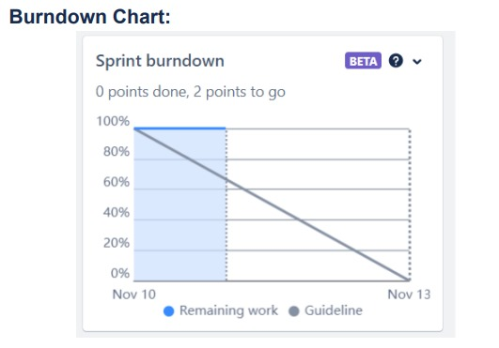

**Timeline:-**

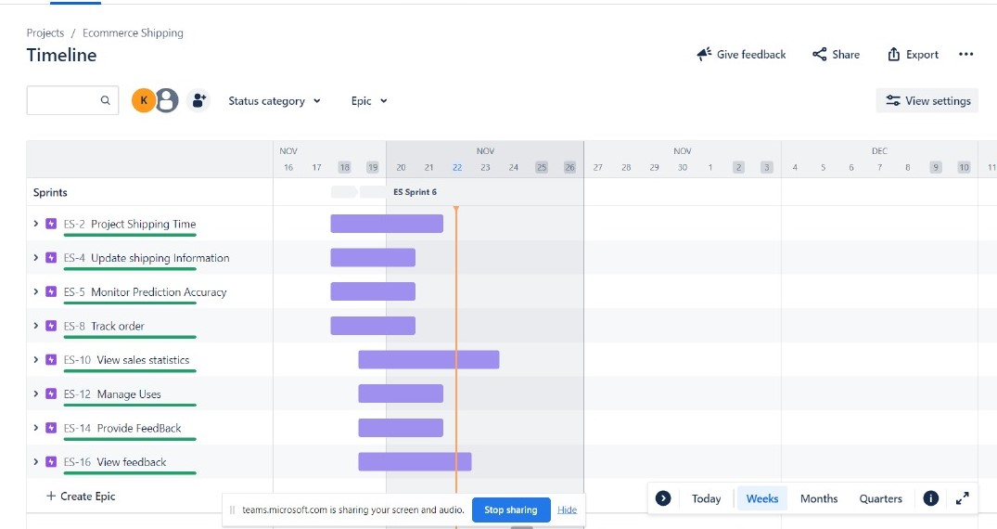

**Velocity**

